1. *List names of employees whose job is MANAGER.*

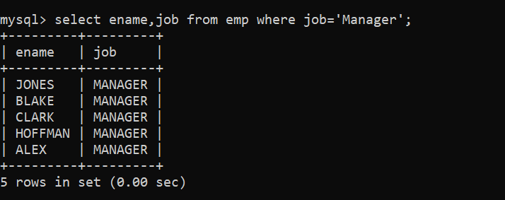

1. *List names of employee having salary greater than equal to 3000.*

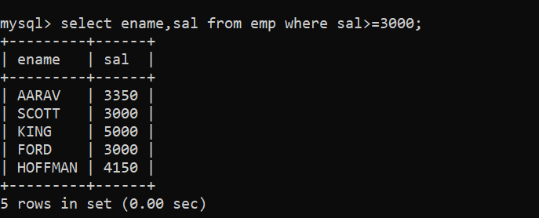

1. *List all employees having ‘A’ as second letter in their names.*

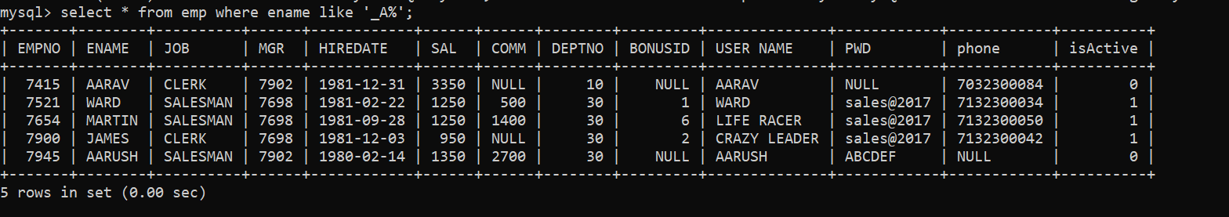

1. *List the Employee Number, Name, Hiredate and Job Title of the Employees in the Department 10.*

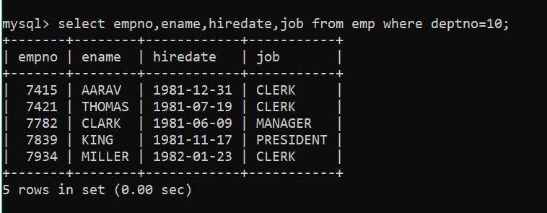

1. *Display the details of those Employees who earn a monthly Salary of more than 2000.*

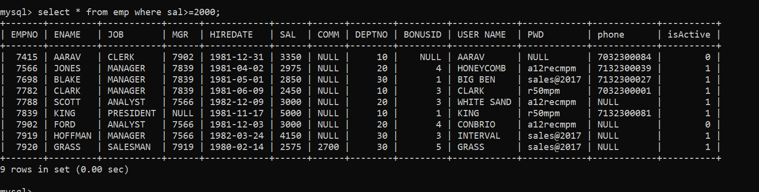

1. *Display the names of all Employees from Department 10 and 20 whose name start with “A” and ends with “B”.*



1. *Display the details of the employees who have joined on 21-DEC-1990.*

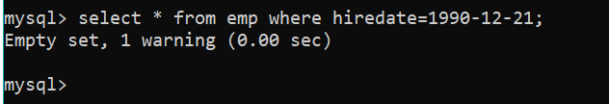

1. *Display the Employee Code, Name, Job & Annual Salary for all Employees belonging to Department Number 10.*

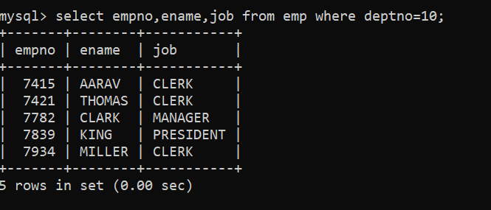

1. *Display the details of the Employees who earn an of more than 25000. Sort the records in the descending order of Salary.*

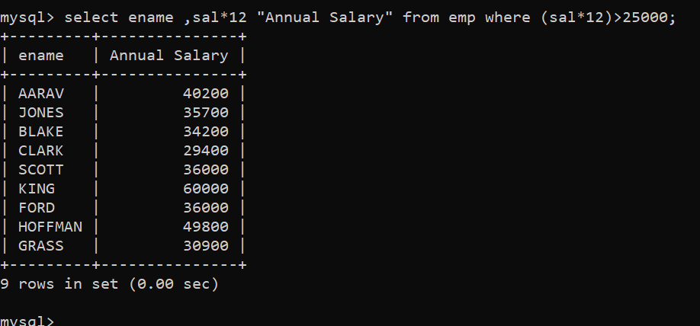

1. *Display the names of Employees whose names contain the character “F”.*

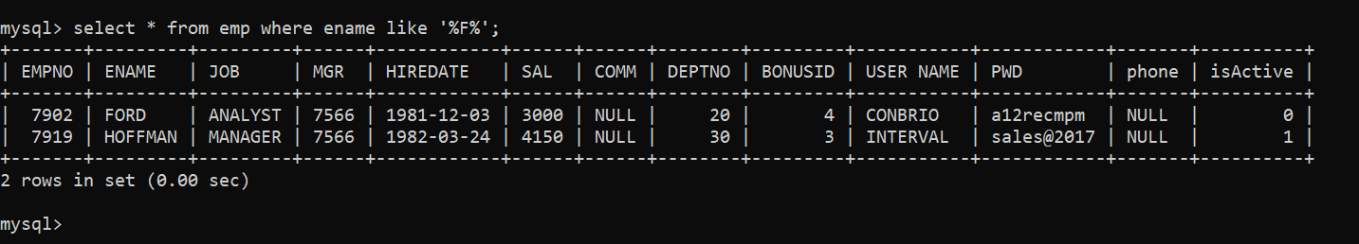

1. *Display the Employee Code, Name, Job & Annual Salary for all Employees belonging to Department Number 10.*
2. *Display the details of the Employees who earn an Annual salary of more than 25000. Sort the records in the descending order of Salary.*
3. *Display the names of Employees whose names contain the character “F”.*



1. *Display the Names and Numbers of all Departments in the descending order of the Department Names.*

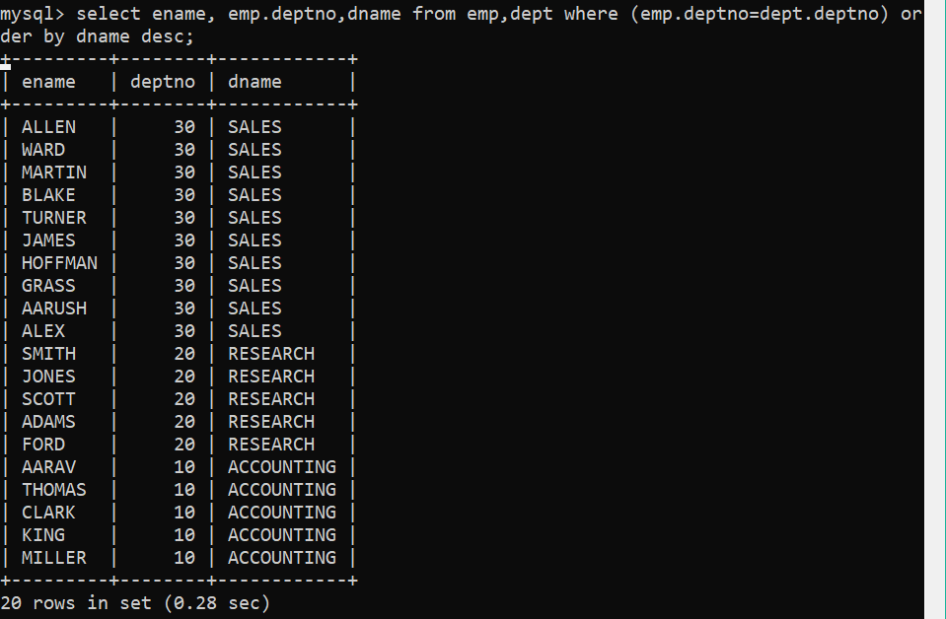

1. *Display the Name, Employee Number, Designation and Salary of those Employees who earn a monthly salary of not less than 1000 and not more than 2000.*

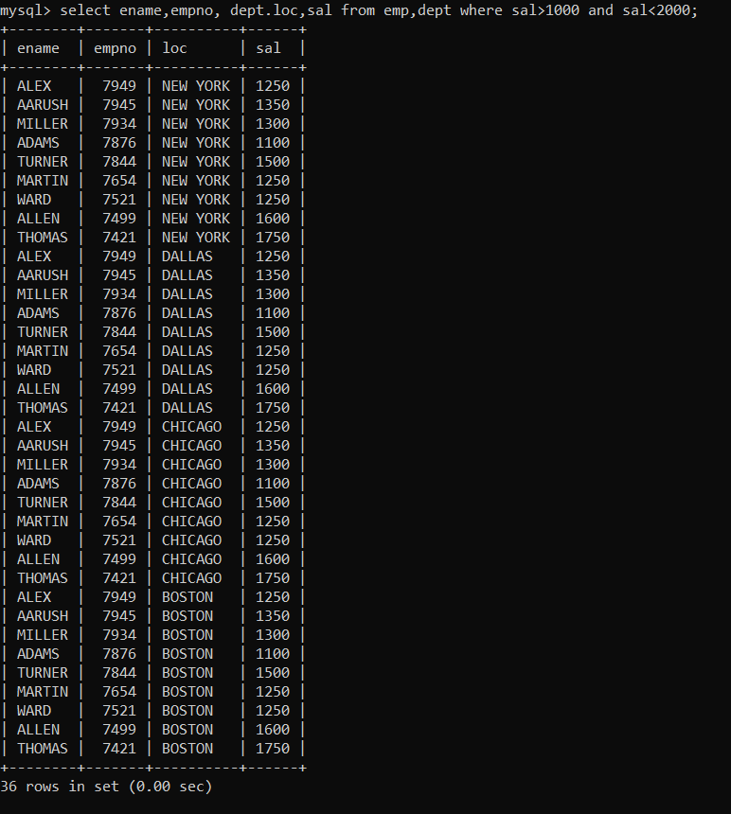

1. *Find out the Bonus (Bonus 1.1% of Annual Salary) that every person will receive at the end of the year.*

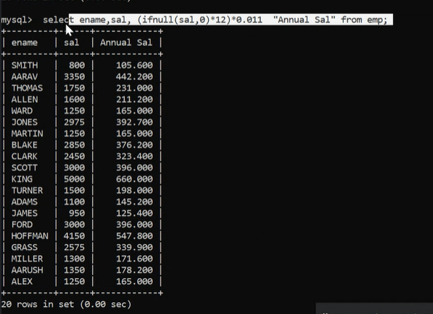

1. *Display the Name, Job and Dept No. of all the Employees who either work in Department 30 or in Department 40.*

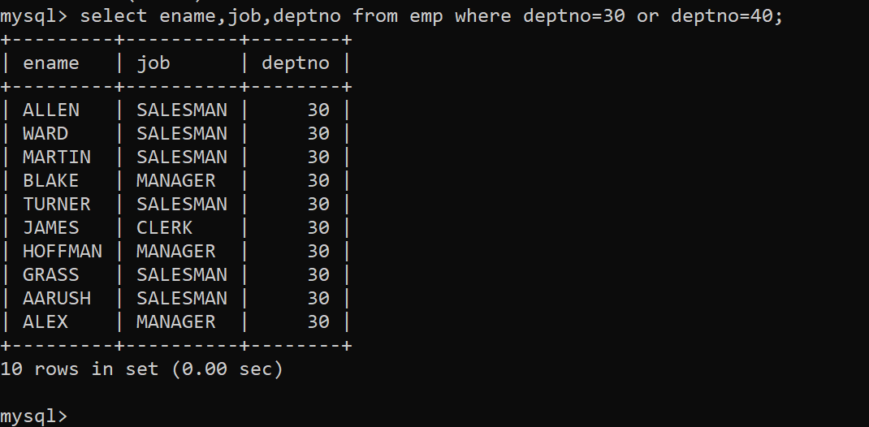

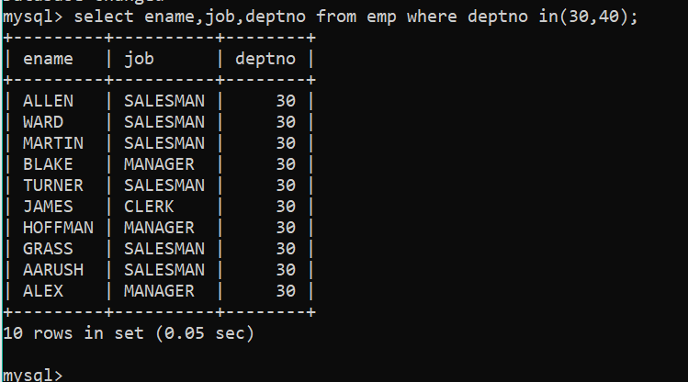

1. *Display the Employee Number, Name for Clerks and Managers who’s Salary is more than 1500.*

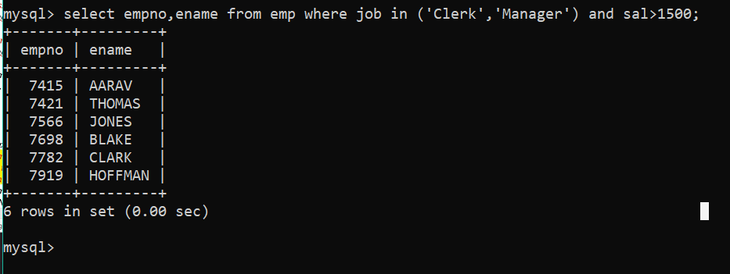

1. *Display the Name, Annual Salary and Commission as “Commission Earned” of all employees whose monthly salary is greater than their Commission. The output should be in decreasing order of salary. If two or more employees have same salary, then sort them by name within the highest order of salary.*
2. *Display the Name and Job of sales executives or managers whose names end with the letter ‘S’.*

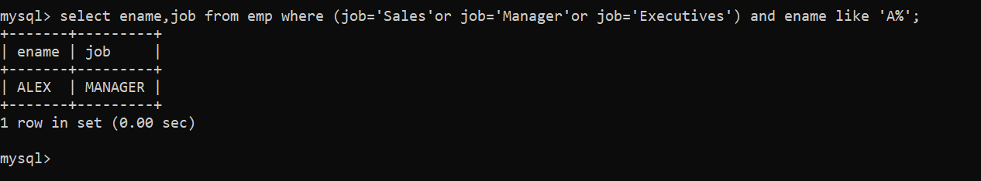

1. *Display all the Names of the Employees whose Salary is either more than 1000 but not more than 2200.*

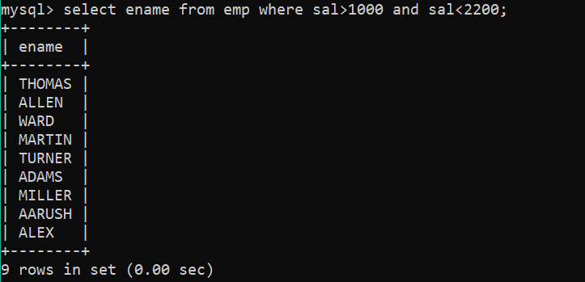

1. *Select Name & Salary of employees who are clerks.*

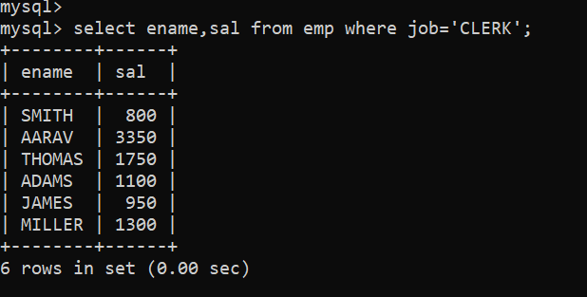

1. *List the Department Number and Names of all Employees having Salary less than 2500.*

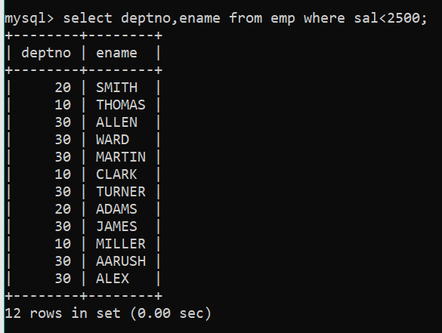

1. *List the Employee Number and the Name of the President.*

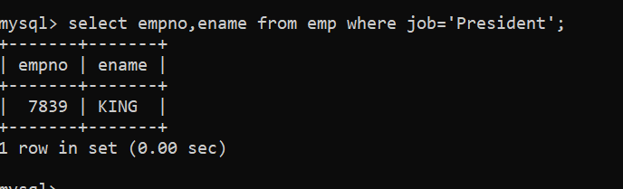

1. *Display Names whose job is either Clerk or Analyst or Salesman.*

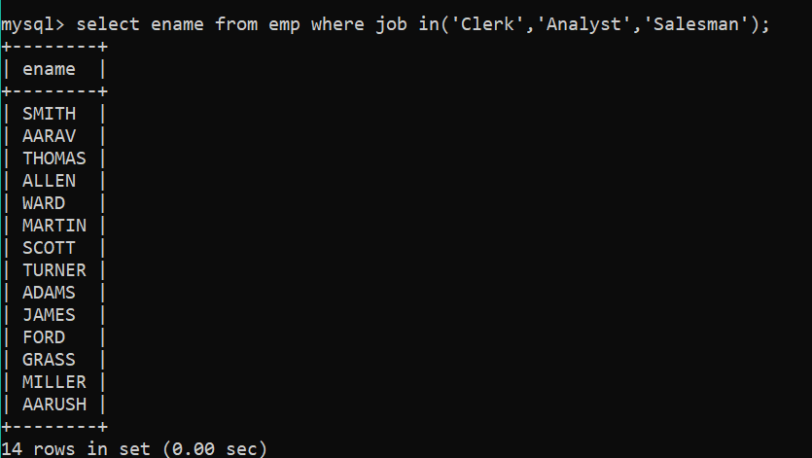select

1. *List the Employees whose names start with ‘B’ or ‘M’*

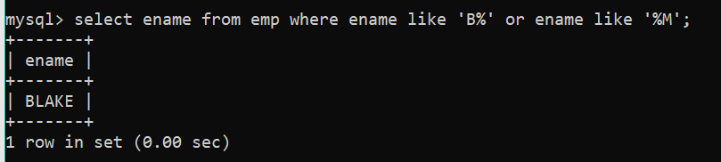

1. *Give a list of Employees sorted in alphabetic order of Names.*

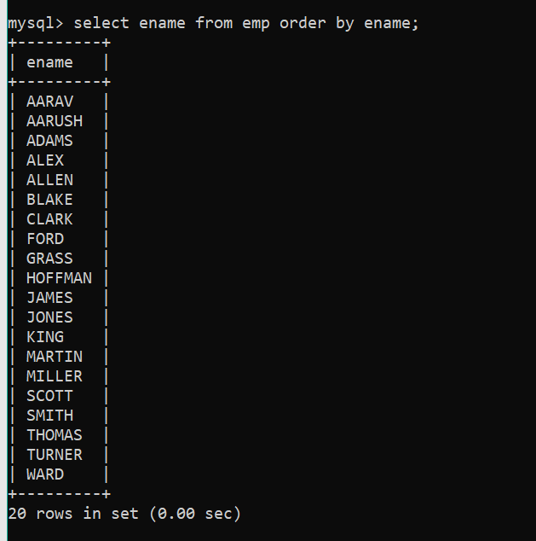

1. *Find out details of Employees where Commission is greater than 5% of the Salary.*

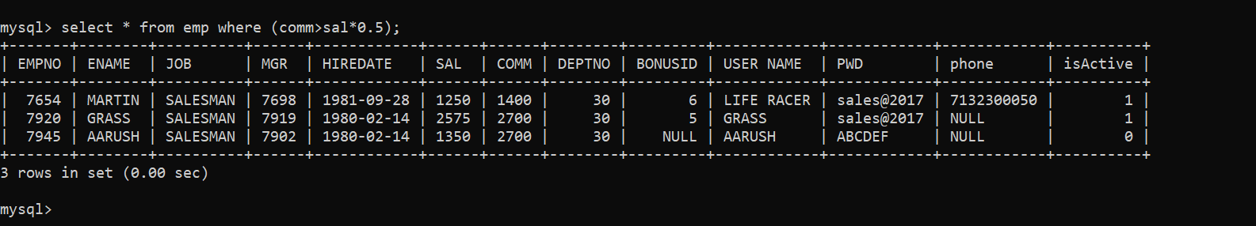

1. *Create query to display the Employee Name and Department Number for empno 7566.*

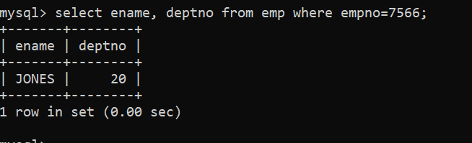

1. *List the Name and Salary of Employees who earn more than $1500 and are in Department 10 or 30. Label the columns NAME and Monthly Salary, respectively.*

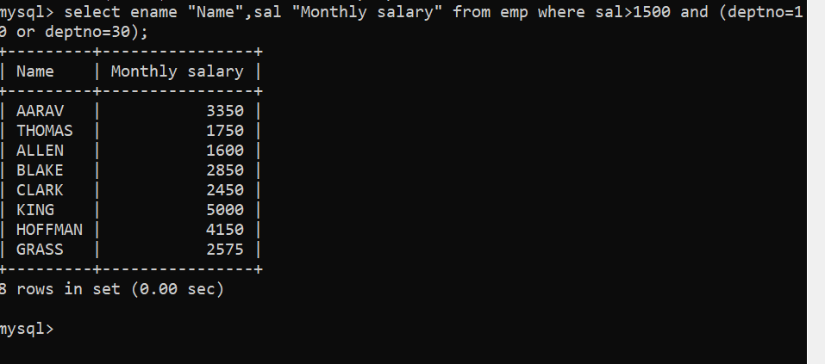

1. *Display the Name, Salary and Commission for all Employees who earn Commission. Sort data in descending order of Salary and Commission.*

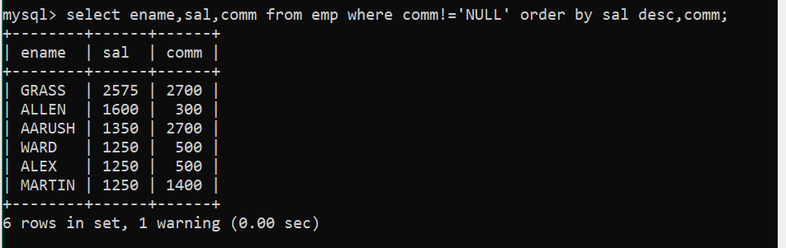

1. *Display the Names of all Employees with the third letter of their Name as an “A”.*

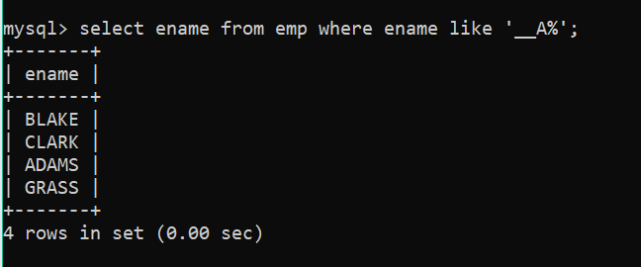

1. *Display the name of all Employees that have two ‘LS’ in the name and are in department 30 or their manager is 7782.*
2. *Display Name, Job & Sal for all Emp whose job is Clerk or Analyst and their Sal is not equal to 1000, 3000 & 5000.*

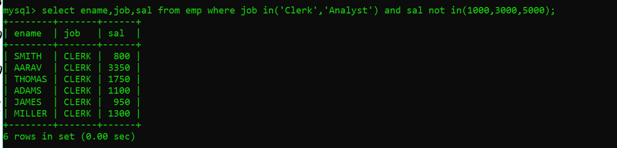

1. *Display the Name, Sal & Comm for all Employees whose Comm amount is greater than their Sal increased by 10%.*

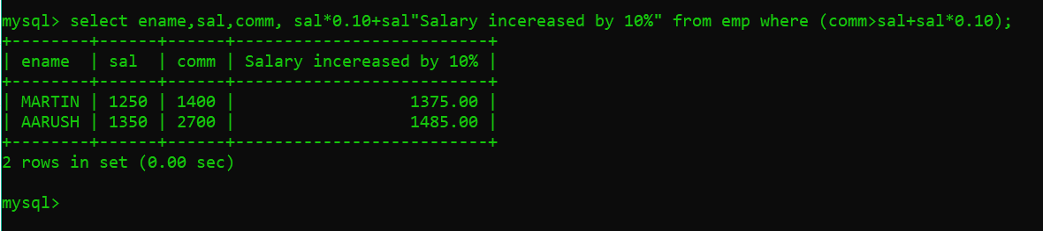

1. *Display Employee Number, Name, Gross Salary (Bonus + Salary\*12 + Commission) for all those Employees who belong to Department Number 20 or 30 in the ascending order of Employee Numbers.*

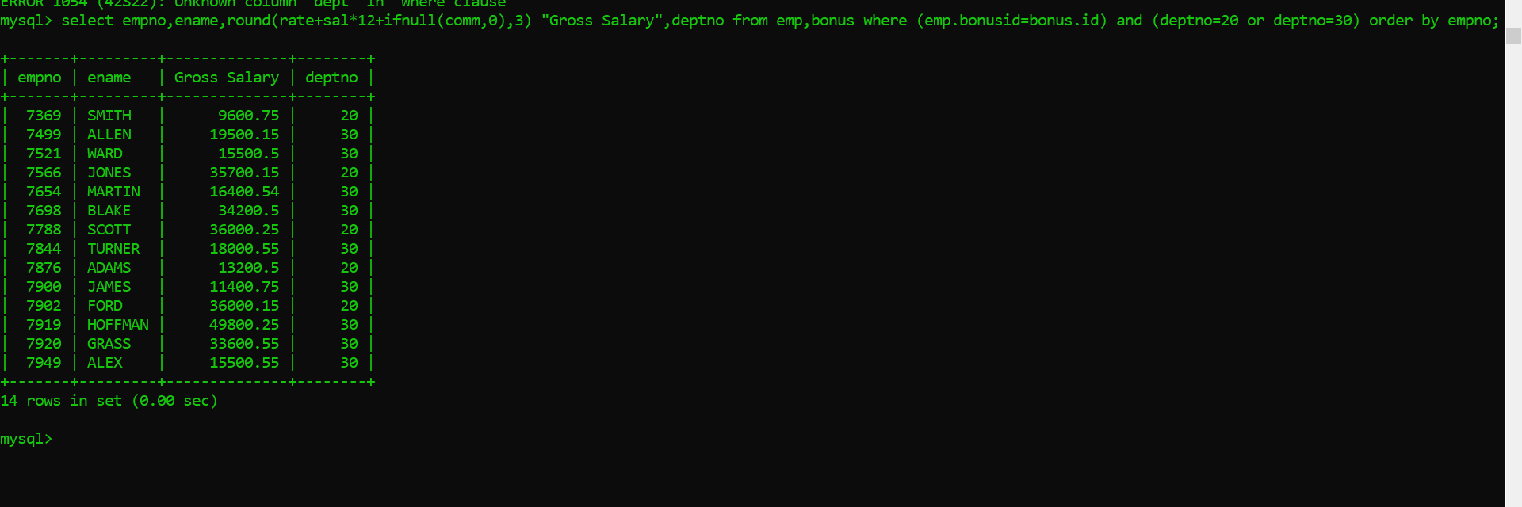

1. *Display the Employee Number, Name, Salary, and Salary Increase by 15% expressed as a whole number. Label the column New Salary.*

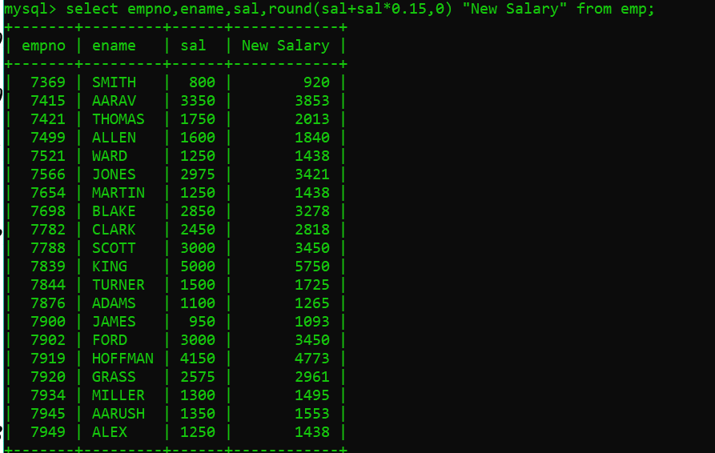

1. *Write a query that will display the employees name with the first letter capitalized an other letters lowercase and the length of their name, for all employees whose name starts with J, A or M.*

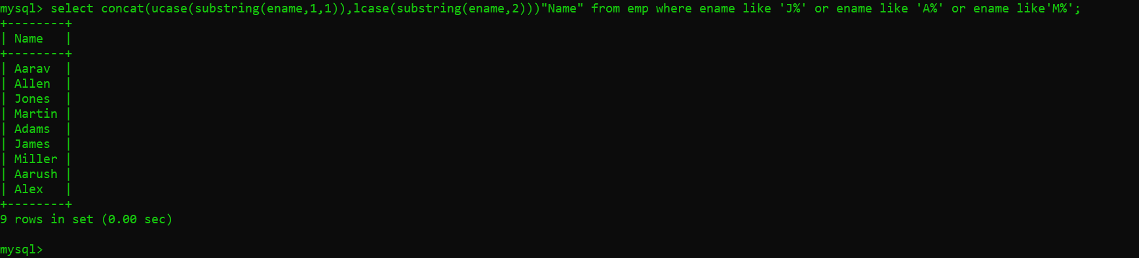

1. *Create a query that will display the Employees name and commission amount. If the employee does not earn commission, put “No Commission”.*

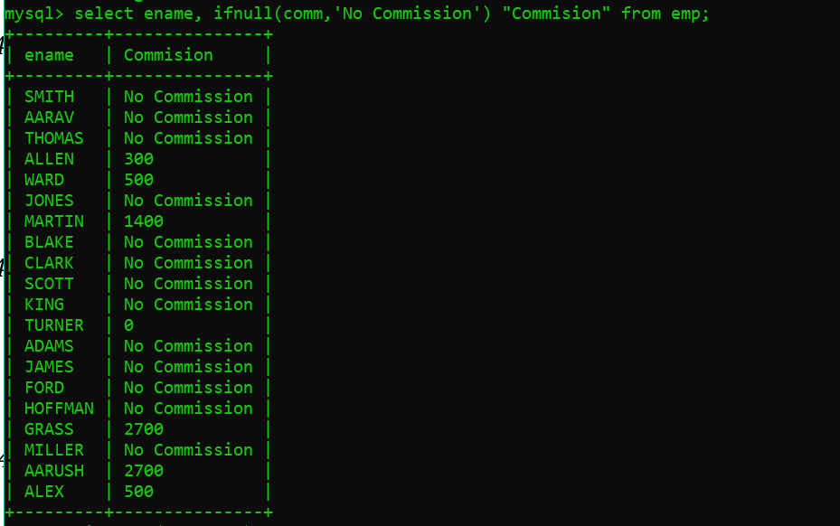

1. *Display Customers Name, Sales Amount approximate Profit Earned (Profit = 8% of Sales Amount) in whole numbers.*
2. *Using the sales table, you need to report the following*
3. *Sales for the first quarter of the year of 1999*
4. *Sales for the product SP TENNIS RACKET*

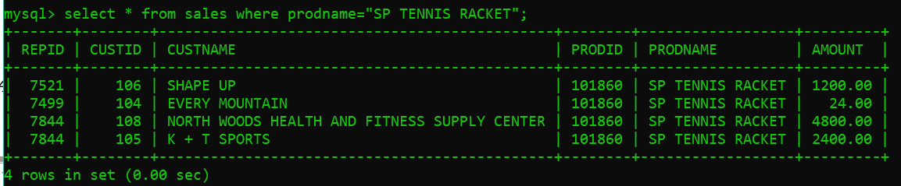

1. *Consider the Customer table. The Credit Limit of all the Customers is increased by 25%. Calculate the new Credit Limit and display the same along with the Name, Repid and Credit Limit for all the Customers. The following should be implemented in the query result set:*
2. *The Credit Limit should be expressed as a whole number, prefixed with a $ symbol.*
3. *Total length of the new Credit Limit should be 10.*
4. *Names of the Customers should be displayed in the title case.*

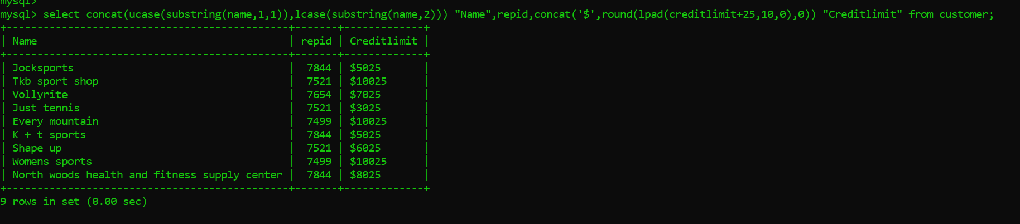

1. *Display the name and the department number of all employees. The department number should be displayed in the following manner:*
2. *If the department number is 10, display ‘Belongs to Dept. 10’*
3. *If 20, display ‘Belongs to the Dept. 20’*
4. *Otherwise display ‘Neither 10 nor 20.’*

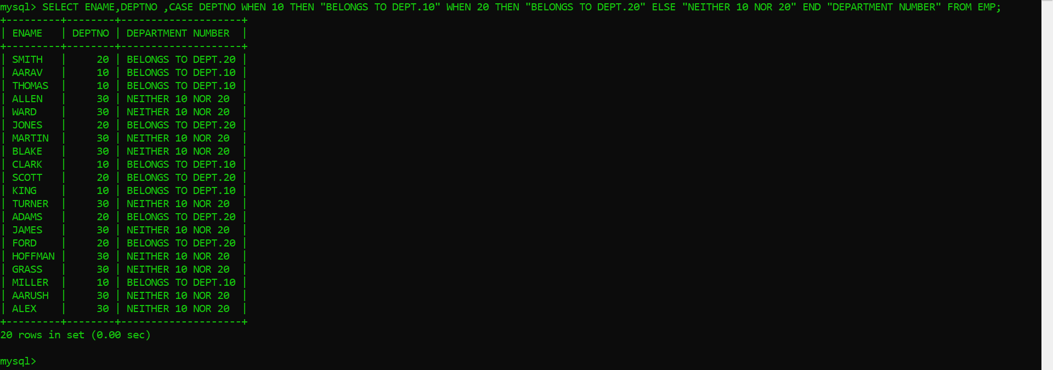

1. *Display the name, first letter of the name (as Abbreviated Name) and the annual compensation for all employees. The following issues should be taken care of:*
2. *The annual compensation has to be calculated by adding the salary and the commission earned by the employee and multiplying the value by 12.*
3. *The first letter of the employee name should be in upper case.*
4. *If the employee does not earn any commission, the commission values should be taken as 600.*

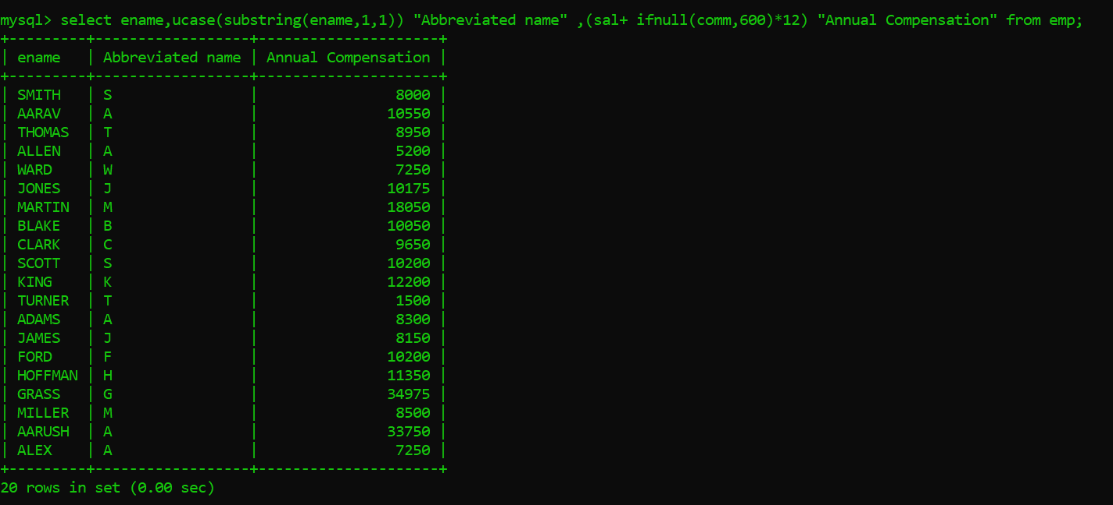

1. *Display the Order ID, the Total Value of the Order and the Commission Plan taking into consideration the following-*
2. *If the Commission Plan is A display it as Anonymous*
3. *If the Commission Plan is B display it as Business*
4. *If the Commission Plan is C display it as Casual*
5. *If no Commission Plan has been mentioned then display Commission Not Allowed*

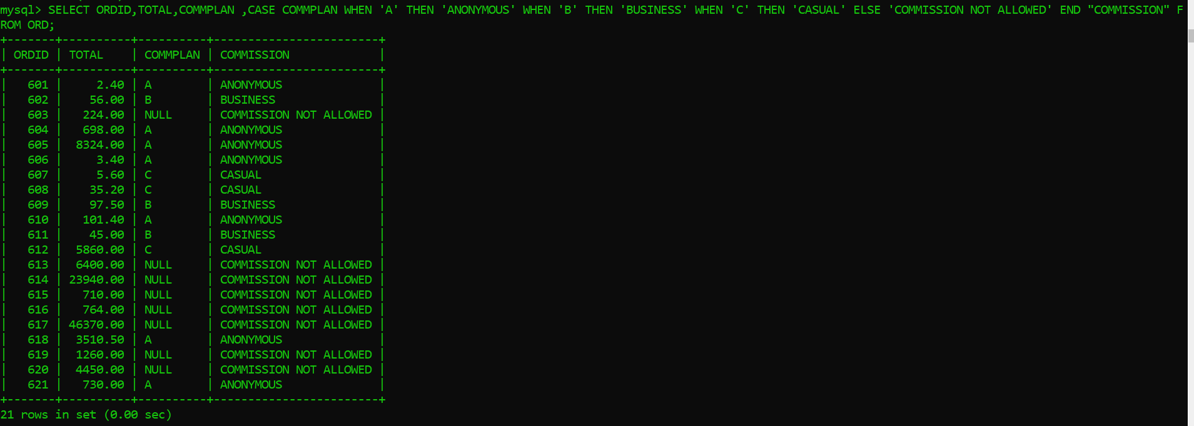

1. *List all the employees who are living in ‘BOSTON’.*



1. *List the names of employees who stay in city whose second letter is ‘A’ or ‘H’.*

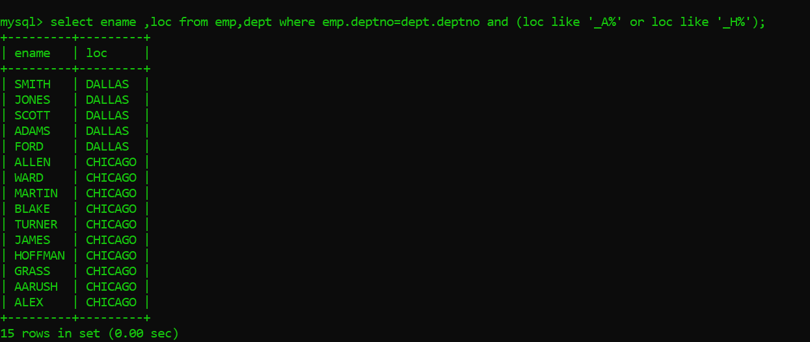

1. *List names of employees who are working in ‘SALES’ department.*



1. *Print the name of employees in the ascending order of employee name.*

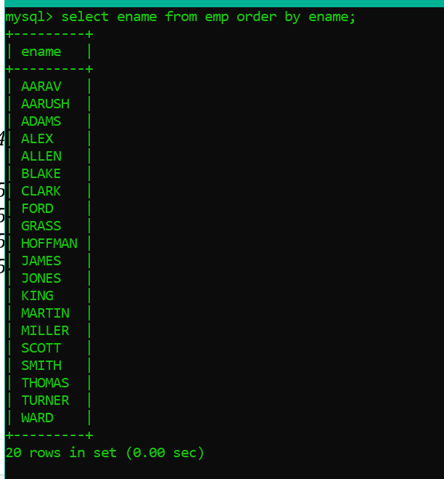

1. *Print employee information in the descending order of salary.*

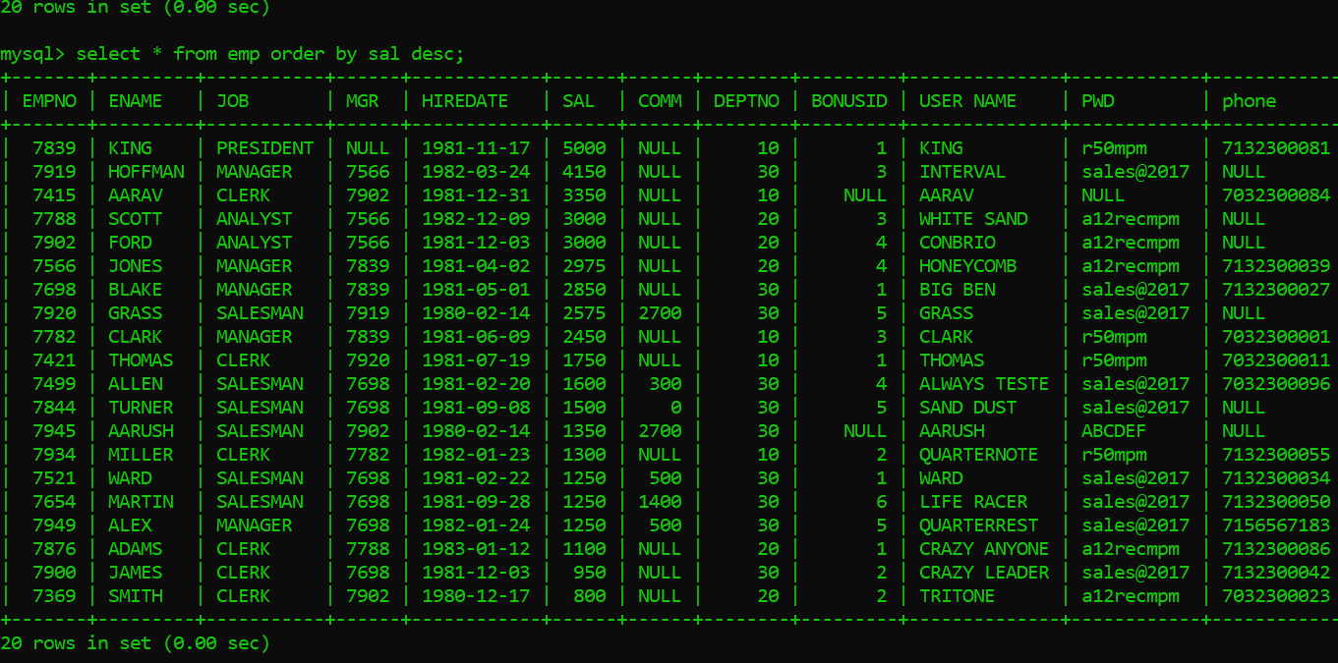

1. *Display employee information in ascending order of year.*

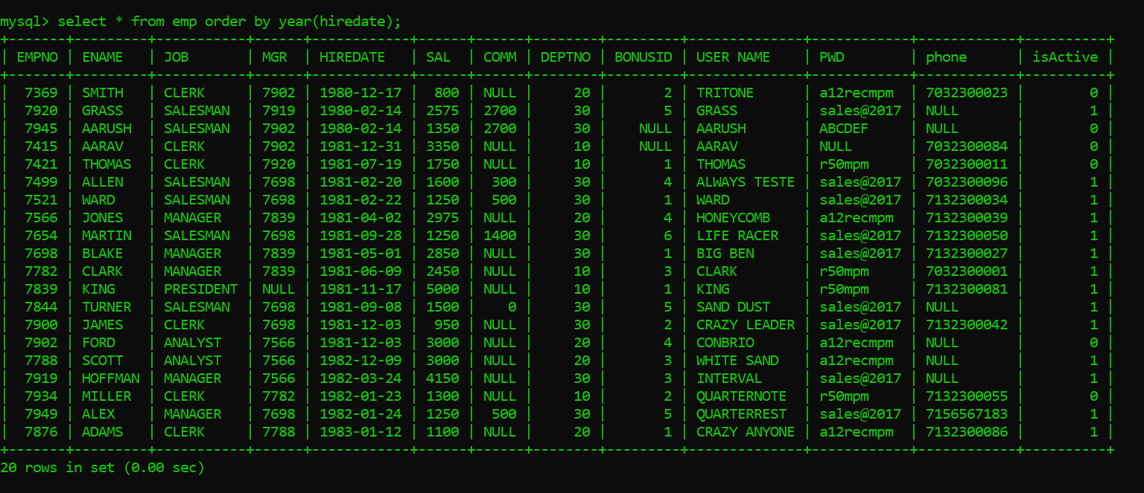

1. *Display job, deptno, names of employee whose name starts with ‘B’ or ‘M’.*

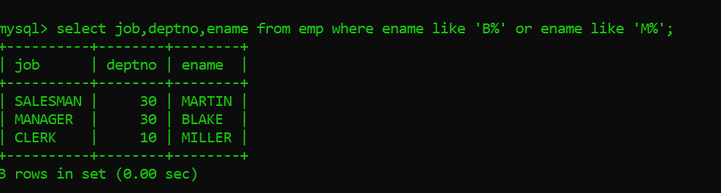

1. *List the employees whose comm is null and salary does not exceed 3000.*

